|  |  |
| --- | --- |
| \\VFILERDPI\DPI-Home\OBRIENR2\My Documents\Downloads\PP logo.jpg |  |
| **COUNCIL ASSESSMENT REPORT**  HUNTER AND CENTRAL COAST REGIONAL PLANNING PANEL | |

|  |  |
| --- | --- |
| PANEL REFERENCE & DA NUMBER | PPSHCC-223  DA/1127/2023 |
| PROPOSAL | Centre-based child care facility |
| ADDRESS | Lot 1 DP 157444, Lot 380 DP 1133165 and Lot 2 DP 730502  38-40 Yorston Street, WARNERS BAY NSW 2282 |
| APPLICANT | |  | | --- | | Lake Macquarie City Council | |
| OWNER | Lake Macquarie City Council |
| DA LODGEMENT DATE | 8 August 2023 |
| APPLICATION TYPE | Development Application |
| REGIONALLY SIGNIFICANT CRITERIA | Clause 3, Schedule 6 of *State Environmental Planning Policy (Planning Systems) 2021*: Council is the applicant for development consent and the owner of the land where the development has an estimated development cost of more than $5 million. |
| CIV | $5,172,400 (excluding GST) |
| CLAUSE 4.6 REQUESTS | N/A |
| KEY SEPP/LEP | * *Environmental and Planning Assessment Act 1979* * *Environmental and Planning Assessment Regulation 2021* * *State Environmental Planning Policy (Biodiversity and Conservation) 2021* * *State Environmental Planning Policy (Industry and Employment) 2021* * *State Environmental Planning Policy (Resilience and Hazards) 2021* * *State Environmental Planning Policy (Transport and Infrastructure) 2021* * *State Environmental Planning Policy (Planning Systems) 2021* * *Lake Macquarie Local Environmental Plan 2014* * *Lake Macquarie Development Control Plan 2014* |
| TOTAL & UNIQUE SUBMISSIONS KEY ISSUES IN SUBMISSIONS | Council has received four submissions and a petition from the initial notification.  One submission was received in response to renotification of amended plans. |
| DOCUMENTS SUBMITTED FOR CONSIDERATION | Access report;  Acoustic report;  Arborists report;  Architectural Plans;  Civil Engineering Plan;  Contamination / Remedial Action Plan;  Crime Risk Assessment;  Geotechnical report;  Landscape Design Plan and Report;  National Quality Framework Assessment checklist;  Traffic and Parking Assessment;  Waste Management Plan; |
| SPECIAL INFRASTRUCTURE CONTRIBUTIONS (S7.24) | N/A |
| RECOMMENDATION | Approval, subject to conditions of consent. |
| DRAFT CONDITIONS TO APPLICANT | YES |
| SCHEDULED MEETING DATE | 9 July 2024 |
| PREPARED BY | Andrew Leese, Development Planner  Reviewed by: Glen Mathews, Section Manager Development |
| DATE OF REPORT | 2 July 2024 |

**EXECUTIVE SUMMARY**

Consent is sought for a two storey centre-based child care facility, catering for 71 children aged 0-5 years, carpark (16 car spaces) and related infrastructure, tree removal and landscaping.

The centre will replace an existing Council owned child care centre located at 49 Charles Street, Warners Bay, just under 250 metres from this site.

The development proposes a building which is divided into five spaces to cater for different student ages, with the second level for staff and administration. A lift to the second level is proposed. The facility seeks to operate Monday – Friday 6.30am to 6.00pm, with the following student breakdown:

16 x children 0-2 years

15 x children 2-3 years

20 x children 3-4 years

20 x children 4-5 years

The subject site is located at 38-40 Yorston Street, Warners Bay, legally known as (Lot 1 DP 157444, Lot 380 DP 1133165 and Lot 2 DP 730502 (‘the site’). The site is triangular in shape with a frontage of 113.655m to Yorston Street to the west; 108.43m to Holt Street to the east; and 40.23 to the neighbouring site to the south.

The site is currently vacant and has an area of approximately 2,110m2.The site contains various native and exotic trees. There is presently no kerb and guttering around the site.

The site is located across two zones, R3 Medium Density Residential and RE1 Public Recreation. Centre-based child care is permitted with consent under both land use tables of the *Lake Macquarie Local Environmental Plan (LEP) 2014*.

The lots zoned RE1 Public Recreation is classified as community land. Council’s Plan of Management applicable to these sites permits child care centres.

The development site is not located within a mine subsidence district.

Advice was sought from Ausgrid for works in the vicinity of overhead powerlines pursuant to the State Environmental Planning Policy (Transport and Infrastructure) 2021 (T and I SEPP). Their response received 8 August 2023 raised no objection and noted standard request with regard to details prior to construction.

The application was placed on public exhibition from 21 July 2023 to 25 August 2023, with four submissions and a petition being received. The submissions raised issues relating to loss of open space, location of waste storage and traffic concerns. A second public exhibition from 10 April 2024 to 17 May 2024 resulted in one submission being received. This submission raised concerns regarding traffic and impact on a nearby intersection. These issues are considered further in this report.

The application is referred to the Hunter and Central Coast Regional Planning Panel (the Panel) as regionally significant development, pursuant to Section 2.19(1) and Clauses 3(a) and (b) of Schedule 6 of *State Environmental Planning Policy (Planning Systems) 2021* being a Council related development over $5 million.

A combined briefing and kick-off meeting was held for the application on 31 August 2023 where key issues were discussed, including streetscape/ building form presentation, setbacks, tree removal and site access.

Initial review of the relevant details relating to the building raised concerns with the setbacks to Yorston and Holt Streets. These have been amended and considered to suitably comply with all relevant controls for streetscape presentation.

The issue of tree removal has been considered and the proposal is deemed acceptable for the purpose of this application. Retention of any tree would result in significant constraints to layout and design, compromising the function of the child care facility. Replacement trees are proposed within the site and along the street frontage.

The redesigned/amended proposal has reduced the parking provided from 17 to 16 spaces. The Lake Macquarie Development Control Plan (DCP) requires 19 car parking spaces. This variation request is considered and discussed in the body of the report.

Appropriate design outcomes and mitigation measures have been included to enable the development to co-exist with other surrounding uses without adverse impacts.

Following a detailed assessment of the proposal, pursuant to Section 4.16(1)(a) of the *EP&A Act*, DA/1127/2023 is recommended for approval subject to the draft conditions of consent attached to this report at Attachment A.

1. **THE SITE AND LOCALITY**
   1. **The Site**

The site is triangular in shape with a combined aera of approx. 2,110m2, consisting of three lots known as 38 - 40 Yorston Street, Warners Bay, (Lot 1 DP 157444, Lot 380 DP 1133165 and Lot 2 DP 730502.) The site is located on the fringe of the Warners Bay town centre and has a secondary street frontage to the east along Holt Street as demonstrated in figure 1 below. The site shares one boundary to a dwelling located at 42 Yorston Street to the south.

The site is currently vacant with various native and exotic trees.

The site has a gentle fall from south to north.

The site is not identified as being within a sensitive Aboriginal landscape area or any identified heritage items.

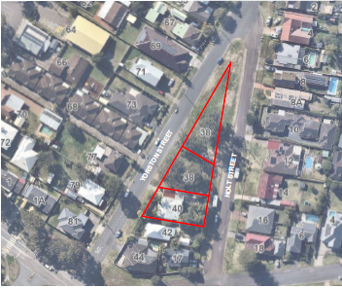

**Figure 1: Map of site**

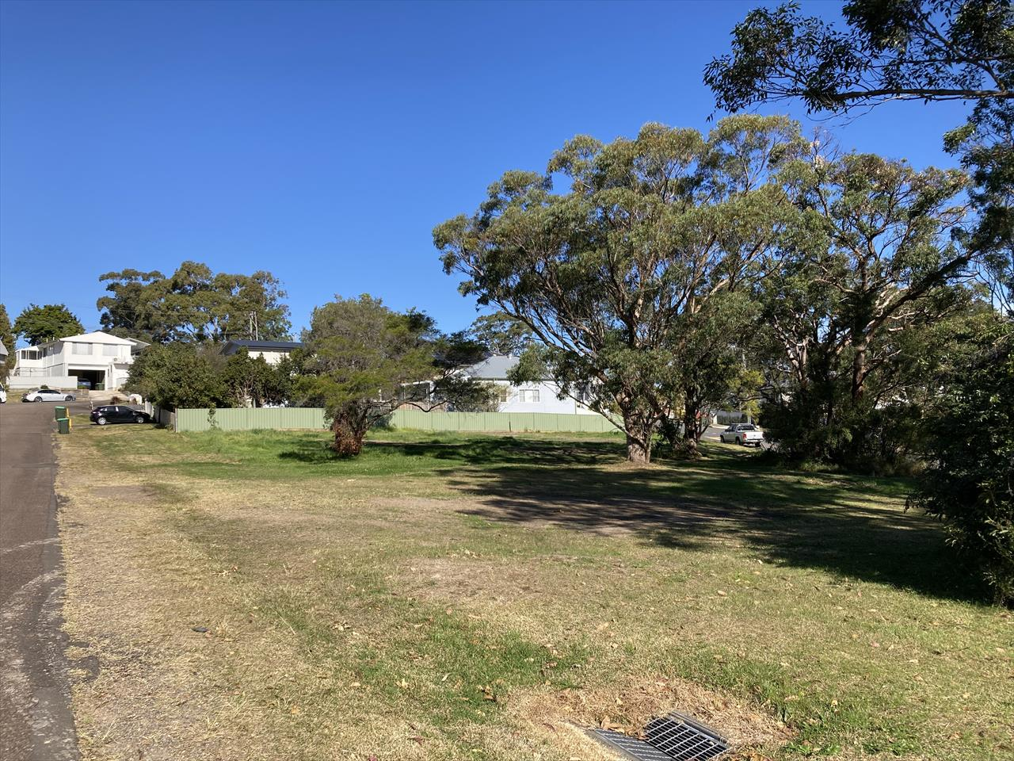

**Figure 2: Site Photo – Looking south-east along Holt Street**

**Figure 3: Site Photo – Looking south-west along Yorston Street**

* 1. **The Locality**

The site is located in the suburb of Warners Bay, within the Lake Macquarie City Council (LMCC) local government area (LGA) as show in figure 4 below.

The site is zoned R3 Medium Density Residential and RE1 Public Recreation – pursuant to Clause 2.3 of the LEP 2014.

Immediately surrounding the site are single storey detached dwellings and a number of multi dwelling housing (single level villa home design) developments.

St Marys Church and Primary School is located south of the site separated by Bayview Street.

The nearest bus stop is on Bayview Street (200 metres to the south), which provides public transport to Charlestown then the greater Newcastle area. Other routes can be accessed via the Warners Bay town centre.

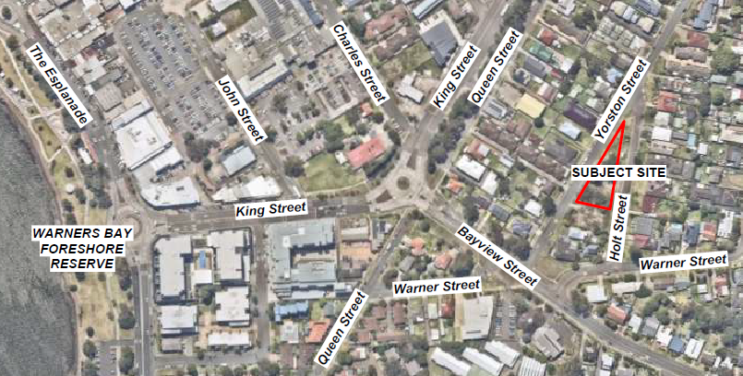

**Figure 4: Map of site and surrounding locality**

1. **THE PROPOSAL AND BACKGROUND** 
   1. **The Proposal**

Consent is sought for a two storey centre-base child care facility, at grade carpark (16 car spaces), with related infrastructure and landscaping.

The proposal includes one building, presented in a U shape with five unencumbered indoor spaces around a central outdoor/play area of over 500m2. To the south the building has a second level which will provide staff rooms and storage, with lift access. The total GFA is approximately 700m2. At the north of the site will be parking for 16 vehicles, 14 of which are proposed in a stacked configuration. The main entry of is located on the north west elevation of the building, fronting Yorston Street.

Site excavation and demolition of existing features such as retaining walls, internal driveways and vegetation are proposed as site preparation works. All trees onsite are proposed to be removed. At the southern end of the site a cut of between 1.2m – 1.8m is proposed.

**Figure 5: Proposed Development – General Layout/ Site Plan**

**Figure 6: Proposed Development – Yorston Street Perspective**

**Table 1: Development Data**

|  |  |
| --- | --- |
| **Control** | **Proposal** |
| Site area | 2,110m2 |
| GFA | 700m2 |
| Clause 4.6 Requests | No – The development does not request a variation to the development standards |
| Max Height | 7.4m |
| Landscaped area | 583m2 / 27% of site |
| Car Parking spaces | 16 on-site car parks |
| Setbacks | 2 - 3m to eastern boundary; 2.4 – 2.5m to southern boundary; 2 – 4m to western boundary built form |

* 1. **Background**

No pre-lodgement meeting was held prior to the lodgement of the application.

The development application was made to Council on 4 July 2023. A chronology of the development application since lodgement including the Panel’s involvement with the application is outlined in Table 2:

**Table 2: Chronology of the DA**

|  |  |
| --- | --- |
| **Date** | **Event** |
| 4 July 2023 | Application made to Council |
| 20 July 2024 | DA referred to external agencies (Ausgrid) |
| 21 July 2023 – 25 August 2023 | Exhibition of the application |
| 8 August 2023 | Lodgement of application |
| 8 August 2023 | Response from Ausgrid |
| 31 August 2023 | Panel briefing |
| 20 September 2023 | Request for Information from Council to applicant |
| 9 April 2024 | Amended plans lodged – primary changes included further improvements to the streetscape presentation of the proposal to reflect outcome of additional information requests. |
| 10 April 2024 – 17 May 2024 | Renotification period of the application |
| 2 July 2024 | Assessment report and draft conditions lodged to Panel |

* 1. **Site History**

The RE1 zoned portion of the site has no development history. This area has never been formalised as a park or play area.

The R3 zoned part of the site was occupied by a single storey detached dwelling until early 2023.

Council approved development application DA/2605/2022 for the demolition of a dwelling at 40 Yorston Street (the R3 portion) of the site on 29 November 2022.

Development Application DA/1127/2023 was made to Council on 4 July 2023, for a centre based child care facility which is currently under consideration.

1. **STATUTORY CONSIDERATIONS**

When determining a development application, the consent authority must take into consideration the matters outlined in Section 4.15(1) of the *Environmental Planning and Assessment Act 1979* (‘EP&A Act’). These matters as are of relevance to the development application include the following:

1. *the provisions of any environmental planning instrument, proposed instrument, development control plan, planning agreement and the regulations*

*(i)  any environmental planning instrument, and*

*(ii)  any proposed instrument that is or has been the subject of public consultation under this Act and that has been notified to the consent authority (unless the Planning Secretary has notified the consent authority that the making of the proposed instrument has been deferred indefinitely or has not been approved), and*

*(iii)  any development control plan, and*

*(iiia)  any planning agreement that has been entered into under section 7.4, or any draft planning agreement that a developer has offered to enter into under section 7.4, and*

*(iv)  the regulations (to the extent that they prescribe matters for the purposes of this paragraph),*

*that apply to the land to which the development application relates,*

1. *the likely impacts of that development, including environmental impacts on both the natural and built environments, and social and economic impacts in the locality,*
2. *the suitability of the site for the development,*
3. *any submissions made in accordance with this Act or the regulations,*
4. *the public interest.*

These matters are further considered below.

* 1. **Environmental Planning Instruments, proposed instrument, development control plan, planning agreement and the regulations**

The relevant environmental planning instruments, proposed instruments, development control plans, planning agreements and the matters for consideration under the Regulation are considered below.

1. **Section 4.15(1)(a)(i) - Provisions of Environmental Planning Instruments**

The following Environmental Planning Instruments are relevant to this application

* [*State Environmental Planning Policy (Planning Systems) 2021*](https://legislation.nsw.gov.au/view/html/inforce/current/epi-2021-0724)
* *State Environmental Planning Policy (Biodiversity and Conservation) 2021*
* [*State Environmental Planning Policy (Resilience and Hazards) 2021*](https://legislation.nsw.gov.au/view/html/inforce/current/epi-2021-0730)
* [*State Environmental Planning Policy (Transport and Infrastructure) 2021*](https://legislation.nsw.gov.au/view/html/inforce/current/epi-2021-0732)
* *Lake Macquarie Local Environmental Plan 2014*
* *Lake Macquarie Development Control Plan 2014*

A summary of the key matters for consideration arising from these State Environmental Planning Policies are outlined in **Table 3** and considered in more detail below.

**Table 3: Summary of Applicable Environmental Planning Instruments**

|  |  |  |
| --- | --- | --- |
| **EPI** | **Matters for Consideration** | **Comply (Y/N)** |
| SEPP (Biodiversity and Conservation) 2021 | Chapter 4 – Koala habitat protection 2021  The site is not a core koala habitat.  Council’s Ecologist has considered the proposal and is satisfied the proposal is acceptable. | Y |
| SEPP Planning Policy (Planning Systems) 2021 | Chapter 2: State and Regional Development  Section 2.19(1) declares the proposal regionally significant development pursuant to Clause 3 of Schedule 6 as it comprises Council infrastructure over $5 million. | Y |
| SEPP (Resilience & Hazards) | Chapter 2: Coastal Management  The proposed development is not considered to have any impacts in relation to coastal impacts  .  Chapter 4: Remediation of Land  Section 4.6 - Contamination and remediation has been considered in the Detailed Site Investigations prepared by Kleinfelder and the site is considered suitable for the proposed use with regards to contamination, subject to conditions. | Y |
| SEPP (Transport and Infrastructure) 2021 | Chapter 2: Infrastructure   * Section 2.48(2) (Determination of development applications – other development) – electricity transmission – the proposal is satisfactory subject to conditions recommended by the electricity supply authority (Ausgrid).   Chapter 3: Education establishments and child care facilities   * Section 3.22 - (Centre-based child care facility—concurrence of Regulatory Authority required for certain development) – the proposal complies with the applicable regulation and as such does not require concurrence of the Regulatory Authority. * Section 3.23 - (Centre-based child care facility—matters for consideration by consent authorities) - requires the consent authority to take into consideration any applicable provisions of the *Child Care Planning Guidelines.* These Guidelines are noted and discussed below. * Section 3.26 - (Centre-based child care facility—non-discretionary development standards) – prevents the consent authority from requiring more onerous standards for a number of matters, including indoor and outdoor space requirements and colour/colour schemes. | Y |
| Proposed Instruments | No compliance issues identified. | Y |
| Lake Macquarie Local Environmental Plan 2014 | * Clause 2.3 – Permissibility and zone objectives. The development is consistent with zone objectives. * Clause 4.3 – The development is below the maximum building height limits of the site. * Clause 7.2 – Earthworks have been considered to meet the provisions under Clause 7.2(3). * Clause 7.21 – The development has demonstrated that essential services are available to the site. | Y |
| Lake Macquarie Development Control Plan 2014 | * Part 3: Development in Residential Zones – The development generally complies with this section of the DCP. * Part 6: Development in Recreation and Tourist Zones – The development generally complies with this section of the DCP. | Y |

Consideration of the relevant SEPPs is outlined below;

State Environmental Planning Policy (Planning Systems) 2021

Chapter 2: State and Regional Development

The proposal is *regionally significant development* pursuant to Section 2.19(1). It satisfies the criteria in Clause 3 of Schedule 6 of the Planning Systems SEPP as development for Council facilities over $5 million.

Accordingly, the Hunter and Central Coast Regional Planning Panel is the consent authority for the application. The proposal is consistent with this Policy.

**State Environmental Planning Policy (Biodiversity and Conservation) 2021**

The site is not mapped on the Biodiversity Values Map and the proposed development will not exceed clearing thresholds set out under Section 7.2 and Section 7.3 of the NSW Biodiversity Conservation (BC) Regulation 2017.

The site is not a core koala habitat and it has limited habitat protected by this policy.

Council’s Development Planner – Flora and Fauna has considered the proposal and is satisfied the proposal is acceptable subject to recommended conditions of consent.

State Environmental Planning Policy (Resilience and Hazards) 2021

Chapter 4: Remediation of Land

The provisions of Chapter 4 of *State Environmental Planning Policy (Resilience and Hazards) 2021 (‘*theResilience and Hazards SEPP’) have been considered in the assessment of the development application.

Section 4.6 of the Resilience and Hazards SEPP requires consent authorities to consider whether the land is contaminated. If the land is contaminated, the consent authority must be satisfied the land is suitable in its contaminated state (or will be suitable, after remediation) for the purpose for which the development is proposed to be carried out.

Assessment of potential contamination has been submitted with the application, including a Detailed Site Investigation (DSI) which identified the presence of bonded asbestos on the site (ACM materials) and zinc concentrations above desirable levels.

A Remedial Action Plan (RAP) was submitted which identified further investigation is required to confirm the exact extent of the ACM materials and the presence of zinc, and recommended several options for the remediation of the site to ensure it is suitable for its intended use. These contaminants and materials are not uncommon, where it is typical for removal from site and disposal off-site at a registered facility. Whilst the RAP submitted with the application includes several remediation options, assessment of the application has concluded the planning outcome required to ensure the provisions of SEPP are achieved, is to condition for the contaminated soils and ACM material to be disposed off-site. A condition of consent will be imposed to require further investigation to be undertaken prior to the release of the Construction Certificate, to identify the exact extent of contaminated soils and materials, to inform the extent of remediation works. The method of disposal will remain the same.

Subject to the remediation works being undertaken, the land will be suitable for the proposed land use and meets the provisions of the SEPP.

**State Environmental Planning Policy (Transport and Infrastructure) 2021**

Chapter 2 Infrastructure – Division 5 Subdivision 2 Development likely to affect an electricity transmission or distribution network

Overhead powerlines run along both Yorston and Holt Streets on the opposite side to the development site. Referral to Ausgrid formed part of the assessment process for comments of these arrangements. Ausgrid provided their comments on 8 August 2023 raising no concerns with the proposal.

Part 3.3 Early education and care facilities – specific development controls

Section 3.22 – Centre-based child care facility – concurrence of Regulatory Authority required for certain development

The proposal does not require the concurrence of the Regulatory Authority, as it complies with the indoor and outdoor unencumbered space requirements.

Section 3.23 – Centre-based child care facility – additional matters for consideration by consent authorities

Detailed considerations of the applicable provision of the Child Care Planning Guidelines are noted below.

Section 3.26 – Centre-based child care facility – non-discretionary development standards

Council is not seeking more onerous standards on the matters raised in this section.

Child Care Planning Guideline (September 2021)

*Site selection and location*

C1 – amenity impacts have been considered in relation to the site’s zoning and location in a residential precinct.

C2 – the site is considered suitable for the proposed use after assessment of the site’s merits.

C3 – the proposal is well located to service the local community.

C4 – the site is not in proximity to hazardous uses.

*Local character, streetscape and the public domain interface*

C5 – the built form will respond to the changing character of the area.

C6 – the proposal has clear delineation between public and private spaces.

C7 – the pedestrian entry is legible.

C8 – N/A

C9 – fencing does not dominate the area.

C10 – no specific acoustic fencing is proposed or required for this development.

*Building orientation, envelope, building design and accessibility*

C11 – impacts on neighbours are minimised.

C12 – the development is located in a medium density residential zone and responds to the character of the area.

C13 – setbacks have now been increased after concerns were raised with the setbacks originally proposed.

C14 – setbacks are considered satisfactory for a medium density residential zone which surround the site, and its proximity to the fringe of a commercial precinct.

C15 – only one main entry is provided. A secondary secure staff entrance is provided along Holt Street.

C16 – universal access is provided and will be reinforced by conditions.

*Landscaping*

C17 – Council’s Landscape Specialist has supported the amended proposal.

C18 - Council’s Landscape Specialist has supported the amended proposal.

*Visual and acoustic privacy*

C19 – N/A

C20 – public overlooking is minimised with the use of fencing and landscaping.

C21 – the building is designed to minimise amenity impacts on the southern residential neighbour.

C22 – the building is located to minimise acoustic impacts on the southern residential neighbour.

C23 – An acoustic report was submitted with the application and considered satisfactory by Council’s Environmental Health officers.

*Noise and air pollution*

C24 – outside noise levels in this location are not excessive.

C25 – N/A

C26 – the site is not located in proximity to significant pollution sources.

C27 – N/A

*Hours of operation*

C28 – the proposed hours of operation are 6.30am to 6.00pm. This falls outside the guidelines’ 7.00am to 7.00pm, with an additional 30 minutes in the morning. Given the spread of child drop offs this starting time is not opposed.

C29 – N/A

*Traffic, parking and pedestrian circulation*

C30 – the proposal does not provide the DCP required number of parking spaces. 19 are required and 16 are provided. The applicant has claimed “there is sufficient on street parking available at appropriate times within proximity of the site”. This claim is not opposed and it is noted that with kerb and guttering being constructed around the site, more efficient on-street parking can be accommodated in the locality.

C31 – N/A

C32 - a traffic report was prepared by Intersect Traffic and lodged with the application. Council’s Traffic Engineer raised no issues with the proposal or the traffic report, which notes that the “road network has spare capacity to cater for additional development in the area,” and does not adversely impact on either the Bayview and Yorston Streets intersection or the King and Bayview Streets roundabout.

C33 – N/A

C34 – N/A

C35 – the proposal will require the construction of a footpath and kerb & guttering for the full length of the site.

C36 – N/A

C37 – safety measures are provided to reduce pedestrian/vehicle conflict.

**National regulations**

*Internal physical environment -* complies with Regulation 107 with 3.35sqaure metres of unencumbered indoor spaces.

Storage – the proposal provides more storage than recommended.

*Laundry and hygiene facilities -* a laundry is provided in accordance with Regulation 106

*Toilet and hygiene facilities –* adequate age-appropriate facilities are provided on site*.*

*Ventilation and natural light –* opportunities for natural light and ventilation have been maximised by the applicant.

*Administrative space –* administrative spaces have been provided.

*Nappy change facilities –* a consistent nappy change facility has been provided.

*Premises designed to facilitate supervision –* glazing is provided to provide adequate supervision by staff of children’s spaces*.*

*Emergency and evacuation procedures –* the childcare operator will need to create new emergency and evacuation procedures.

*External physical environment –* Regulation 108 requires 497m2 of open space, with 564m2 provided.

*Natural environment –* Proposed landscaping will provide opportunities for sensory experiences and learning opportunities.

*Shade –* adequate shade is to be provided*.*

*Fencing –* fencing is designed to act as a suitable barrier.

*Soil assessment –* the site does not pose any unmanageable risk – noting remediation has been considered above.

**Lake Macquarie Local Environmental Plan 2014**

The relevant local environmental plan applying to the site is the LEP. The aims of the LEP include to promote the efficient and equitable provision of public services, infrastructure and amenities. The proposal is consistent with these aims, providing childcare services to meet the needs of the local and wider community.

The site was located within the R3 – Medium Density Residential and RE1- Public Recreation pursuant to Clause 2.2 of the LEP.

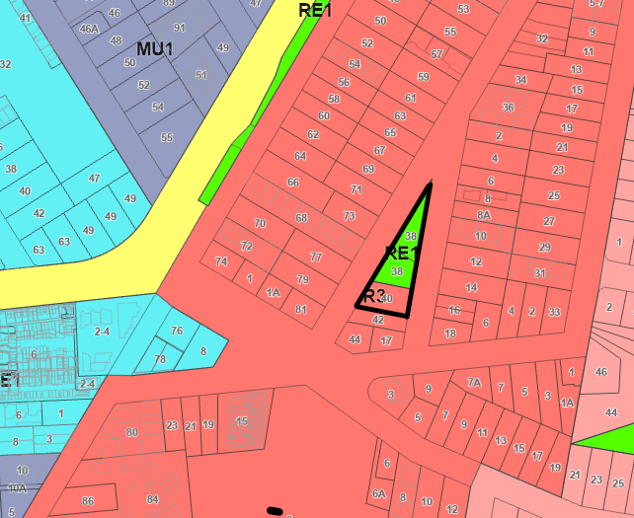

**Figure 7: Land Zone Map**

The zone objectives are:

**R3 Medium Density Residential**

* *To provide for the housing needs of the community within a medium density residential environment.*
* *To provide a variety of housing types within a medium density residential environment.*
* *To enable other land uses that provide facilities or services to meet the day to day needs of residents.*
* *To maintain and enhance the residential amenity and character of the surrounding area.*

**RE1 Public Recreation**

* *To enable land to be used for public open space or recreational purposes.*
* *To provide a range of recreational settings and activities and compatible land uses.*
* *To protect and enhance the natural environment for recreational purposes.*
* *To facilitate the preservation of the environmental qualities of land.*

The proposal is consistent with these zone objectives for the following reasons:

* The development will provide an essential service that can serve the needs of the local and wider community and is compatible with other surrounding land uses.
* Maximises opportunities for public transport usage, co-location of education related services and services / facilities within the Warners Bay town centre.

The LEP also contains controls relating to development standards, miscellaneous provisions and local provisions. The controls relevant to the proposal are considered in Table 4 below.

**Table 4: Consideration of the LEP Controls**

|  |  |  |  |
| --- | --- | --- | --- |
| ***Lake Macquarie Local Environmental Plan 2014*** | | | |
| Control | Requirement | Proposal | Comply |
| Height of buildings  (Cl 4.3(2)) | 10 metres (R3)  8.5metres (RE1) | The maximum building height of the development will be 7.4 metres. | Yes |
| Earthworks  (Cl 7.2) | Will not have a detrimental impact on environmental functions and processes, neighbouring uses, cultural or heritage items or features of the surrounding land | It is considered the extent of earthworks are consistent with the matters for consideration under this clause. A cut of up to 1.8m is proposed at the south eastern end of the site. The retaining wall is in excess of half a metre from the site boundary.  No objections have been raised. | Yes |
| Essential Services  (Cl 7.21) | Supply of water, electricity, management of sewage, stormwater drainage, vehicle access | All essential services are available to the development. | Yes |

1. **Section 4.15 (1)(a)(ii) - Provisions of any Proposed Instruments**

There are no draft provisions appliable to this site or proposed use.

1. **Section 4.15(1)(a)(iii) - Provisions of any Development Control Plan**

The following Development Control Plan is relevant to this application:

* Lake Macquarie Development Control Plan 2014 (‘the DCP’)

Part 3 Development in Residential Zones and Part 6 Development in Recreation and Tourist Zones.

The proposal is generally consistent with the controls listed under Parts 4 and 6 of the DCP.

A summary of the key matters for consideration arising from the DCP are outlined in Table 5.

**Table 5: Summary of DCP controls**

|  |  |  |
| --- | --- | --- |
| **Part 3 – Development in Residential Zones** | | |
| Control | Consideration | Comply |

|  |  |  |
| --- | --- | --- |
| Geotechnical  (S2.3) | A suitable geotechnical report prepared by Kleinfelder (dated 22 June 2023) has been submitted and is considered satisfactory. A condition will be placed on the consent requiring compliance with the recommendations of the report. | Y |
| Contaminated Land (S2.5) | Potential contamination was discovered. A condition will require to rehabilitation of the site pre CC in accordance with the prepared RAP. | Conditioned |
| Acid Sulphate Soils (S2.6) | The site is located on the 500m buffer zone around areas with a higher risk of having Acid Sulphate Soils (ASS).  The Geotech report found no presence of ASS. | Y |
| Stormwater Management (S2.7) | Council’s Development Engineer notes a suitable Stormwater Management Plan incorporating detention, water harvesting, water quality facilities and site discharge index requirements in accordance with the Lake Macquarie DCP 2014 has been provided. The plan is considered adequate for DA purposes. | Y |
| Flora and Fauna (S.2.12) | The application was referred to council’s Planner – Flora & Fauna. They raised no objection to the proposal, subject to conditions around the timing of and inspection prior to tree removal. | Y |
| Preservation of Trees and Vegetation (S2.13) | Council’s Arborist does not object to the proposed tree removal, subject to the implementation of the proposed landscape plan. | Y |
| Social Impact (S2.17) | The proposal will not have any adverse social impacts. | Y |
| Economic Impact (S2.18) | The proposal will not have any adverse economic impacts. | Y |
| Streetscape (S.3.1) | The proposal responds to the future character of the area as a medium density zone. | Y |
| Street Setback (S3.2) | Setbacks to Yorston Street range from 2 – 4 metres.  Setbacks to Holt Street range from 2 - 3 metres.  Consideration needs to be taken of neighbouring front setbacks, noting that secondary street setbacks on corner allotments is a minimum of two metres  Yorston Street is taken to be the main frontage for the development site. The portion of the frontage which is setback 2 metres is not consistent with the established setback or the 4 metre control in the R3 and RE1 zones with no neighbouring development. However, consideration is provided to the irregular shape of the lot and impact this has on the ability to provide built form, the standalone nature of the site and impact on existing development in the vicinity.  The design provides a stepped form with a 4 metre setback where adjoining existing development to compliment the established setback pattern in Yorston Street and not result in an undesirable streetscape presentation.  Sufficient room for plantings along this façade has been provided with the area of non compliance being 13.8m which is only 12% of the total Yorston Street frontage.  The variation to the Yorston Street setback is considered to maintain the objectives of the control and is acceptable in this instance.  Holt Street is taken to be the secondary street frontage and the 2 metre setback proposed meet this control. | N |
| Side Setback (S3.3) | The southern setback is considered to be a side setback which provides in excess of 2 metres to the boundary.  Council controls require 900mm for development up to 4.5m above existing ground level and 1.5m for development greater than 4.5m in height.  The proposed development exceeds the minimum side setback control. | Y |
| Rear Setback  (S3.4) | There are no defined rear setbacks with this proposal. | Y |
| Site Coverage (S3.5) | General site coverage in the R3 zone is 50% and no controls for the RE1 zone.  The development complies with this requirement providing 46% (974m2) coverage. | Y |
| Building Bulk (S3.6) | The visual impact of the development is minimised by the majority single level design, proposed setbacks, articulation of built form and large portion of unbuilt area to the north – the most visually prominent part of the site. | Y |
| Roofs (S3.8) | Roof forms should not be dominant. It is considered that the roof forms do not dominate this development. |  |
| Solar Access and Orientation (S3.10) | Shadow diagrams provided by the applicant demonstrate the northern side of the No 44 Yorston Street will be in shadow at 9am on the winter solstice, but by noon and in the afternoon overshadowing is limited, with no overshadowing of the dwelling itself.  Shadow diagrams have demonstrated the development does not unreasonably impact on solar access of adjoining land users. | Y |
| Acoustic Privacy (S4.1) | An Acoustic Report was lodged with the application and found to be acceptable by Council’s Environmental Management team, subject to conditions. | Y |
| Landscaped Area (S4.2) | The proposal provides approximately 27% (583m2) of the site as landscaped area. This falls short of the desired 45% for lots of this size in the general residential controls, but exceeds the 20% required for multi-dwelling housing and residential flat buildings, which are the most likely development in the R3 zone surrounding this site. (There are no applicable RE1 controls.) | N |
| Landscaped Design (S4.3) | The proposed landscaping has been prepared by a qualified Landscape Architect and is suitable level for the development proposed. | Y |
| Traffic and Transport (S4.7) | Vehicle access is generally consistent with the DCP and is supported by Council’s Development and Traffic Engineers.  The Traffic Report concludes the proposal will not have an adverse impact on local traffic conditions. | Y |
| Design of Parking and Service Areas (S4.8) | Council’s Development Engineer has not raised concerns with the parking layout/arrangement. | Y |
| Car Parking Rates (S4.11) | The proposed car parking does not meet the required rates of the DCP.  19 spaces are required and 16 spaces are provided. 14 of these spaces are in a stacked arrangement.  The stacked arrangement is not opposed as this is a common for a child care centres and permitted by the DCP, noting that spaces in the stacked location are for staff use and do not require high turn over.  The deficiency of three spaces is not opposed for the following reasons. The site has good public transport access, kerb and guttering will formalise on-street parking along the permitter of the site and there is extensive availability of on-street parking in immediate proximity to the development.  The variation is also under 20% which is the maximum reduction identified in the DCP controls. | N |
| Non- Discriminatory Access (S4.12) | An Access Report prepared by Lindsay Perry Access (26 June 2023) demonstrates the fundamental aims of accessibility legislation is achievable for the development.  Council’s Access officer has raised concerns with the location of the motor bike parking space and its impact on the accessible parking space. Conditions will be provided for removal of the motorcycle space. | Y |
| Safety and Security (S4.13) | The CPTED Report provided with the application has been reviewed and supported by Council's Community Planner – Youth and Safer Communities, with additional conditions recommended to ensure appropriate lighting, CCTV installation and coverage. | Y |
| Cut and Fill (S4.14) | To provides levels appropriate for the proposed development a cut will be created at the southern end of the site with a maximum height of 1.8m below existing ground level.  This will allow for a level building pad, enable universal access and reduce the impacts in terms of privacy and overshadowing to the southern neighbour.  Council’s Development Engineer is generally supportive of the proposed cut and fill subject to recommended conditions of consent and the location of the cut would not have an adverse impact on the amenity of any adjoining land user. | Y |
| Demolition and Construction Waste Management (S5.1) | Council’s Waste officer has not raised objections to the proposal, subject to conditions. | Y |
| Operational Management  (S5.2) | Council’s Waste officer has not raised objections to the proposal, subject to conditions. | Y |
| Erosion and Sediment Control (S5.5) | Standard conditions will require erosion and sediment control. | Y |
| Air Quality (S5.6) | No adverse impacts, with the kitchen being fitted out and exhausted in accordance with the applicable Australian Standard | Y |
| Noise and Vibration (S5.7) | An acoustic report has been prepared by Muller Acoustic Consulting (dated June 2024).  The report makes various recommendations to ensure that potential acoustic impacts resulting from construction and centre operations will be adequately ameliorated.  This report will be an approved document. | Y |

|  |  |  |
| --- | --- | --- |
| **Part 6 – Development in Recreation and Tourist Zones (Issues that are not raised in or have different requirements matters in Part 3)** | | |
| Control | Consideration | Comply |

|  |  |  |
| --- | --- | --- |
|  |  |  |
| Setbacks from Residential Zoned Land (S3.5) | The boundary between residential and recreation zoning falls over the development and as such this matter is not applicable. | Y |
| Landscape and Tree Planting in Car Parks (S3.15) | The proposed car park is provided with suitable plantings to provide screening and future shade protection. | Y |

* **Lake Macquarie Plan of Management for Community Land 2011**

The site is classified community land pursuant to the *Local Government Act 1993.*  This Act requires Plans of Management for such land. The site is further classified as ‘park’. The Plan of Management allows Community Facilities including childcare to be approved on community land.

The recently adopted Council Parks and Play Strategy has identified this land as unsuitable for a park. Based on this, the land has limited opportunity for the benefit of the community as vacant land and it is believed the use for a child care centre will have a wider benefit. The revised draft Community Land Plan of Management has identified for this land to be recategorized as general community use which will be the most suitable categorisation for the proposed development.

Based upon the support through the Glendale Catchment Development Contributions Plan for the childcare centre to be relocated, and the Parks and Play Strategy recommending the proposed land as unsuitable as a park area, the use of 38 Yorston St, Warners Bay for a child care centre is supported.

* **Council - related Development Application Conflict of Interest Policy and Procedure**

This policy provides a management strategy for applications where Council is the land owner land and the applicant or developer.

Management statement for applications where Council is the land owner land and the applicant

|  |  |
| --- | --- |
| **Council-related development application conflict of interest management statement** | |
| **Council is the land owner and the applicant or developer** | |
| Management strategy and controls | **Public exhibition**  The application will be publicly exhibited for 28 days. |
| **Assessment**  Assessment of the application by council staff not involved in preparing application.  Assessment staff must use typical communication and contact methods (such as contact via phone or email, or making an appointment to meet).  All Council staff involved in the preparation, design and making of a development application must use typical communication and contact methods (such as contact via phone or email, or making an appointment to meet). |
| **Determination**  Assessment report reviewed by direct supervisor.  Determination by Hunter and Central Coast Regional Planning Panel. |
| Note: the application will be assessed in accordance with the *Environmental Planning and Assessment Act 1979.* | |

* Lake Macquarie City Council Section 7.12 Development Contributions Plan

The following contribution plan is relevant pursuant to Section 7.18 of the EP&A Act and have been considered in the recommended conditions, (notwithstanding Contributions plans are not DCPs they are required to be considered.)

1. **Section 4.15(1)(a)(iiia) – Planning agreements under Section 7.4 of the EP&A Act**

There have been no planning agreements entered into and there are no draft planning agreements being proposed for the site.

1. **Section 4.15(1)(a)(iv) - Provisions of Regulations**

Section 61 of the 2021 EP&A Regulation contains matters that must be taken into consideration by a consent authority in determining a development application.

A condition will be imposed to ensure demolition complies with the provisions of AS2601 as required. There are no other matters for consideration under the Regulations.

* 1. **Section 4.15(1)(b) - Likely Impacts of Development**

The likely impacts of that development, including environmental impacts on both the natural and built environments, and social and economic impacts in the locality must be considered.

In this regard, potential impacts related to the proposal have been considered in response to SEPPs, LEP and DCP controls outlined above and the Key Issues section below.

Accordingly, it is considered the proposal will not result in any significant adverse impacts.

* 1. **Section 4.15(1)(c) - Suitability of the site**
* It is located within proximity to the commercial precinct of Warners Bay, dominated by retail and minor commercial services.
* The site is ideally located on a collector road and near a public transport corridor that links Warners bay to the greater Newcastle Area.
* There are adequate services and infrastructure nearby that can support and co-exist with the development.
* The proposed built form is considered to be responsive to the site attributes and its context and setting.
  1. **Section 4.15(1)(d) - Public Submissions**

Six submissions were received in relationship to this application. These submissions have been considered in Section 3 of this report.

* 1. **Section 4.15(1)(e) - Public interest**

The centre-base child care facility proposal is in the public interest for the following reasons:

* The proposed development is consistent with the relevant State and local legislation.
* The proposed development will not impact the health or safety of the public.
* The proposed development will provide economic benefits by means of job creation throughout the construction period and ongoing operations.
* Potential impacts to the traffic and noise have been assessed as having minimal impacts.
* The proposed development will provide social benefits through the creation of additional child care services.
* The proposed development is consistent with the strategic direction for the Hunter and Lake Macquarie region.
* The development is considered to achieve balanced and orderly outcomes.
* The development has demonstrated no significant amenity impacts will arise now or in the future, subject to the imposition and compliance with recommended conditions of consent.

1. **REFERRALS AND SUBMISSIONS** 
   1. **Agency Referrals and Concurrence**

The development application has been referred to various agencies for comment/concurrence/referral as required by the EP&A Act and outlined below in Table 7.

**Table 7: Concurrence and Referrals to agencies**

|  |  |  |  |
| --- | --- | --- | --- |
| **Agency** | **Concurrence/**  **referral trigger** | **Comments**  **(Issue, resolution, conditions)** | **Resolved** |
| Concurrence Requirements (s4.13 of EP&A Act) | | | |
| N/A – Concurrence was not required under this application | | | |
| Referral/Consultation Agencies | | | |
| Electricity supply authority – Ausgrid | Section 2.48 – *State Environmental Planning Policy (Transport and Infrastructure) 2021*  Development near electrical infrastructure | The application was referred to Ausgrid who raised no objection to the development and recommended conditions regarding construction related matters. | Y |
| Hunter Water Corporation (HWC) | Section 51 of Hunter Water Act 1991 | HWC provided endorsed plans reference number 87843, noting, the site has connection to sewer and water and is clear of Hunter Water Assets. | Y |

* 1. **Council Officer Referrals**

The development application has been referred to various Council officers for technical review as outlined **Table 8.**

**Table 8: Consideration of Council Referrals**

|  |  |  |
| --- | --- | --- |
| **Officer** | **Comments** | **Resolved** |
| Waste | Council’s Waste Planning and Policy Officer Specialist has reviewed the waste management plan provided, and confirmed the proposal satisfactorily demonstrates the site and operations can accommodate the anticipated waste volumes. Conditions for determination have been provided | Yes |
| Traffic | Council’s Traffic Engineering officer reviewed the proposal and raised no concerns in relation to traffic generation and car parking, excluding items raised by the Development Engineer. | Yes |
| Landscape | Further information was requested regarding streetscape and boundary treatments.  The revised design incorporated these amendments and is considered satisfactory. Suitable conditions have been provided. | Yes |
| Engineering | Further information was requested regarding stormwater management and overland flow.  The officer is now supportive of the development.  All engineering documentation is considered satisfactory and is supported, with conditions. | Yes |
| Flora and Fauna | The officer is supportive of the development and confirmed there are no requirements for a Biodiversity Development Assessment Report or offsets.  Conditions have been provided around clearing protocols to minimise potential impacts to fauna from the proposed development. | Yes |
| Arborist | Council’s Tree Management Specialist officer has reviewed the application and had no fundamental objection to the proposal. | Yes |
| Assets | Council’s Assets teams has noted that:   1. The relocation of the Warners Bay child care centre was identified in the Glendale Catchment Development Contributions Plan. While the specific location for the relocation has changed the intent has remained the same and within close proximity. 2. The community land at 38 Yorston St, Warners Bay identified for the relocation of the centre, is identified as park within the Community Land Plan of Management 2011. The recently adopted Parks and Play Strategy has identified this land as unsuitable for a park. Based on this, the land has limited opportunity for the benefit of the community as vacant land and it is believed the use for a child care centre will have a wider benefit. 3. The revised draft Community Land Plan of Management has identified for this land to recategorized as general community use which will be the most suitable categorisation for the proposed development. | Yes |
| Accessibility | Council’s Community Planner – Ageing and Disability officer is supportive of the development, subject to motorbike parking be located so that it does not interfere with the shared zoned to the accessible parking bay.  Conditions will be included for the relocation/ removal of motor bike parking. | Yes |
| Safety and security (CPTED) | Council’s Community Planner – Youth and Safer Communities officer supported the recommendations in the CPTED report and provided recommended conditions of consent “to strengthen mitigation of crime”. | Yes |
| Environmental Management | Council’s Environmental Health Officer is supportive of the development.  Conditions are recommended for acoustic certification of the recommendations of the Acoustic Report.  In relation to the contamination issues, a Remedial Action Plan (RAP) has been prepared and submitted. Conditions are recommended around the timing of decontamination of the site and the presentation of required certification. | Yes |
| Environmental Management – Food | Council’s Environmental Health Officer has reviewed the development and provided conditions to ensure appropriate fit out of food preparation areas. | Yes |
| Development contributions | A response has been provided with initial calculation of applicable fees under section 7.12. These contributions will form part of any consent under this application. | Yes |

* 1. **Community Consultation**

The proposal was notified in accordance with the Lake Macquarie Community Participation Plan from 21 July 2023 until 25 August 2023 and again from 10 April 2024 until 17 May 2022. The notification included the following:

* Notification letters sent to adjoining and adjacent properties (26 properties notified).
* Notification on the Council’s website.
* Notification for a occurred for a 28 day period in accordance with to Council related Development Application Conflict of Interest Policy and Procedure.

The Council received a total of 6 unique submissions. The issues raised in the submissions are considered in **Table 9:**

**Table 9: Community Submissions**

|  |  |  |
| --- | --- | --- |
| **Issue** | **No of submissions** | **Council Comments** |
| Garbage / recycling location – visual impact | 3 | The garbage bin enclosure was originally a stand alone structure at the northern most end of the site. Bin storage has been relocated to the southern side of the site and will be set below the neighbouring residential property. |
| Loss of trees / open space | 3 | The loss of tree and informal recreational space is noted.    The Warners Bay area has significant open space, with reserves along the Lake front and 500m to the west are dedicated sporting ovals and local play areas.  Street planting along with planting in the car park, the outdoor play area and three large trees at the northern (pointy) end of the site will replace trees lost by the development. |
| Car Parking | 2 | It is noted that 19 car parking spaces are required by Council’s DCP and 16 are provided.  This is a deficiency of three parking spaces.  The upgrade to Holt Street could see 15 on street car parking spaces provided. These could be lined to demarcate parking spaces available in the street. |
| Traffic impacts | 2 | The submitted Traffic Assessment has indicated there is capacity within the road network to cater for the development and local intersections will remain at acceptable service levels. |
| Driveway widths | 1 | The amended plans and proposed driveway widths have been supported by Council’s Development Engineer as appropriate to service the development as proposed. |

1. **KEY ISSUES**

The following key issues are relevant to the assessment of this application having been raised by the Panel, considered against the relevant planning controls and the proposal in detail:

* 1. **Built Form – Setbacks**

The Panel noted its concerns with setbacks to the street frontages.

With ‘corner’ sites there can be conjecture as to which is the main street frontage and which is the secondary street frontage.

Based on neighbouring residential development the southern boundary is taken to be a side setback, Holt Street as the secondary street frontage and Yorston Street as the main street frontage.

The side setback complies with council controls as does the secondary street setback of 2 metres along Holt Street.

The main street frontage to Yorston Street provides a setback ranging from 2 – 4 metres for the built form. A 4m setback to Yorston Street has been provided adjacent to the existing dwelling at 42 Yorston Street, demonstrated in figure 8 below. The 4m setback is continued for this entire section of the U shaped building with central outdoor area then providing a break in built form. The second section of the U shape building then presents a 2m building setback. The 2 metres setback extends for only 13.8m of the 113m boundary length, or 12% of the frontage.

**Figure 8: Setbacks of the main building – as amended**

The proposed built form achieves a sympathetic response to the existing and desired future context, and the building facades contribute positively with high quality architecture and can provide visual interest to the existing streetscape character, with playful circular windows and low-level planting.

The variation to the setback is in a location impacted by the irregular shape development lot and steps have been taken to ensure the variation is not offensive to the established setback character. Given the isolated location at the end of the street block it does not set a standard which is undesirable or would be replicated to adversely affect streetscape amenity in the locality.

Articulation has been provided to all sides of the proposed building, providing interest and detail at a pedestrian scale and level.

**Figure 9: View of the streetscape along Yorston Street**

Additional landscaping has been implemented along the street frontages and within the site to enable screening and add vertical scale to soften the developments streetscape presentation.

On balance of the outcomes presented and steps taken to mitigate the impacts of the variation to the street setback pattern, the variation is supported.

* 1. **Tree Removal and Loss of Open Space**

The Panel questioned the need for removal of all trees on the site. Council’s Arborist has not opposed the development.

The retention of trees that are centrally located on site would have a significant impact on the design and useability of the site.

Council acknowledges to allow for retention of any tree would require significant amendments to layout and design, compromising the function and viability of the site for any development. Noting Council’s review that the site is unsuitable for a park, significant retention of existing vegetation would likely impact on viability of development site of the site.

Council’s arborist provided the following in their referral comments:

*Considering the high-risk environment, and the various structural defects the existing trees display consistently across the site, no concerns are raised from an arboricultural perspective, noting the extensive replacements as detailed in the submitted landscaping plans.*

To supplement the loss of vegetation the applicant has, in the amended proposal increased the tree replacement and provided for feature landscaping at the northern end of the site.

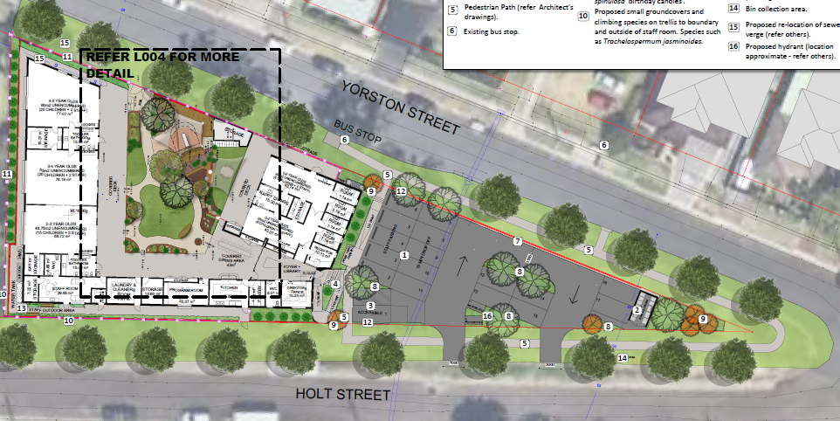

**Figure 10: Initial Proposed Tree Replacement / Landscaping**

**Figure 11: Revised Tree Replacement / Landscaping**

In addition to the health and conditions of tree’s Council’s Development Planner - Flora and fauna has reviewed the assessment and considers the removal appropriate subject to conditions for all salvageable hollows to be relocated off site and for pre-clearance fauna surveys. These conditions will form part of any consent to off-set the impacts of the tree removal occurring on the site.

Council raises no objections to this approach and support the tree removal subject to appropriate conditions for the replacement tree planting, habitat supplementation, and clearing protocols.

* 1. **Car Parking**

The proposal provides 16 on-site car parking spaces. A variation is sought, as 19 spaces are required per the DCP 2014:

1 per 8 students – 71 students = 8.875 (9 spaces)

0.75 per 1 staff - 13 staff = 9.75 (10 spaces)

9 students and 10 staff = 19 space requirement

The Traffic & Parking Assessment report (addendum 1/12/23), prepared by InTersect Traffic seeks a variation based on the following:

*The deficiency is minor (16%) – Council’s controls stipulate a “reduction to the car parking rate must not exceed 20%...., which this development satisfies.*

*Availability of on-street parking – with a number of 15min parking zones to be considered*

*Efficiency of provision and use of car parking spaces*

It is noted the development will install kerb and guttering around the site, which will formalise on street parking, with the option of marking spaces (up to 15) along the Holt Street frontage. The site is located in an area with good public transport access and street parking is not congested.

The neighboring bus stops are for school based buses only. The footpath on the western side of Yorston Street links to the bus stops in Bayview Street.

The parking infrastructure is required to be designed and constructed in accordance with Australian Standards.

Council is satisfied that parking has been suitably resolved.

* 1. **Waste storage**

The standalone bin structure originally proposed at the northern end of the stie has been removed and replaced with planting. Bins will now be stored along the southern side of the building away from public’s view.

* 1. **Acoustic impact**

Council’s Environmental Health staff have raised no objection to the acoustic impact and ability for development to operate without impact on the amenity of adjoining land users.

Standard conditions around construction in accordance with the acoustic report, and an assessment 90 days into the site’s operation, that it is complying with the proposed noise levels and acoustic controls are recommended.

* 1. **Fencing**

Fencing to the main children’s play area will front Yorston Street, will consist of a concrete block wall with ‘window’ perforations (refer to figure 12 below). This will provide a high level of privacy to the main outdoor play area and increase acoustic control.

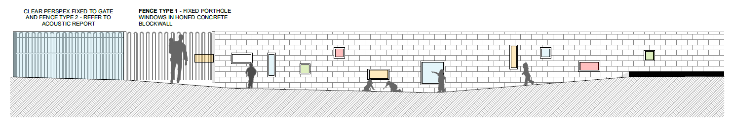

**Figure 12 – Proposed fencing treatment to Yorston Street**

* 1. **Scope of variation to DCP controls**

The applicant is seeking DCP variations on the provision of car parking and setbacks to Yorston Street.

Discussion on these variations has been made. These variations have been supported as it is considered the development as proposed meets the objectives of the controls being varied and will not result in any adverse environmental impacts.

**CONCLUSION**

This development application has been considered in accordance with the requirements of the EP&A Act and the Regulations as outlined in this report.

The site is capable of accommodating the development with an acceptable level of impact.

The proposal has a high-quality design and is supported by design measures to improve the existing streetscape. The sitting is appropriate and the proposed landscaping will improve the public domain, amenity and the presentation of the building and the site the surrounding public areas.

The carparking does not meet the requirements of Council’s DCP, but upgrades to adjoining streets will formalise on-street parking adjacent to the site, making a variation acceptable.

Following a thorough assessment of the relevant planning controls, issues raised in submissions and the key issues identified in this report, it is considered that the application can be supported.

It is considered that the key issues as outlined in Section 5 have been resolved satisfactorily through amendments to the proposal and/or in the recommended draft conditions at **Attachment A**.

1. **RECOMMENDATION**

That the Development Application DA/1127/2023 for centre-based child care facility at 38 – 40 Yorston Street Warners Bay be APPROVED pursuant to Section 4.16(1)(a) of the *Environmental Planning and Assessment Act 1979* be approved subject to the draft conditions of consent attached to this report at Attachment A.

The following attachments are provided:

* Attachment A: Draft Conditions of consent
* Attachment B: Supplementary plans